Supplemental materials
Figure legends
Supplementary Fig. 1. Bootstrapped difference test for edge weight of trauma, rumination and self-injury addiction self-injury addiction network.
Supplementary Fig. 2. Bootstrapped test for confidence intervals of edge, EI and BEI of trauma, rumination and self-injury addiction network.
Supplementary Fig. 3. Bootstrapped difference test for expected influence of trauma, rumination and self-injury addiction network.
Supplementary Fig. 4. Network comparison test between addicted and non-addicted groups.

Supplementary Table 1. Edge weight matrix of the trauma, rumination and self-injury addiction network.
 | A | EN | EA | PN | PA | SA | RRS1 | RRS2 | RRS3
A | 0.00
EN | 0.00 | 0.00
EA | 0.13 | 0.29 | 0.00
PN | 0.04 | 0.35 | 0.12 | 0.00
PA | 0.01 | -0.01 | 0.41 | 0.09 | 0.00
SA | 0.08 | -0.15 | 0.14 | 0.11 | 0.28 | 0.00
RRS1 | 0.23 | 0.07 | 0.11 | 0.09 | -0.03 | -0.05 | 0.00
RRS2 | 0.00 | -0.08 | 0.03 | -0.11 | 0.00 | -0.01 | 0.59 | 0.00
RRS3 | 0.00 | 0.00 | 0.06 | 0.05 | 0.00 | 0.04 | 0.29 | 0.30 | 0.00

Supplementary Table 2. Basic information and network inference of items used to self-injury addiction, trauma and rumination (N=1,169)
Nodes | Label | EI | BEI
OSI-A
self harm addiction | A | -0.09 | 1.58
CTQ
Emotional neglect | EN | -1.07 | -0.71
Emotional abuse | EA | 1.54 | 0.83
physical neglect | PN | -0.43 | -0.39
physical abuse | PA | -0.27 | -0.73
sexual abuse | SA | -1.56 | -0.36
RRS
symptom rumination | RRS1 | 1.20 | 1.21
brooding | RRS2 | 0.11 | -1.43
reflective pondering | RRS3 | 0.57 | 0.01

Supplementary Fig. 1. Bootstrapped test for confidence intervals of edge, EI and BEI of trauma, rumination and self-injury addiction network
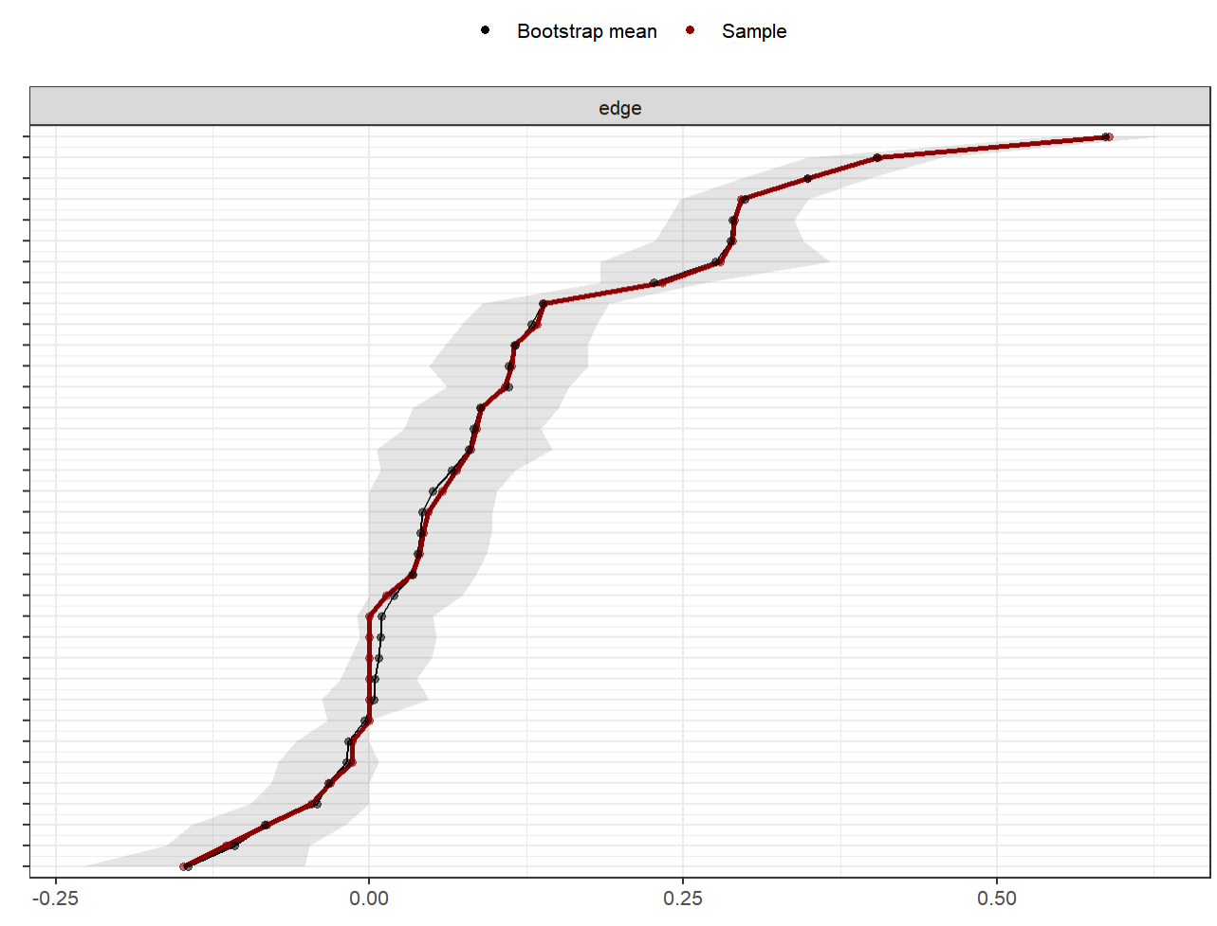

Supplementary Fig. 2. Bootstrapped difference test for edge weight of trauma, rumination and self-injury addiction self-injury addiction network
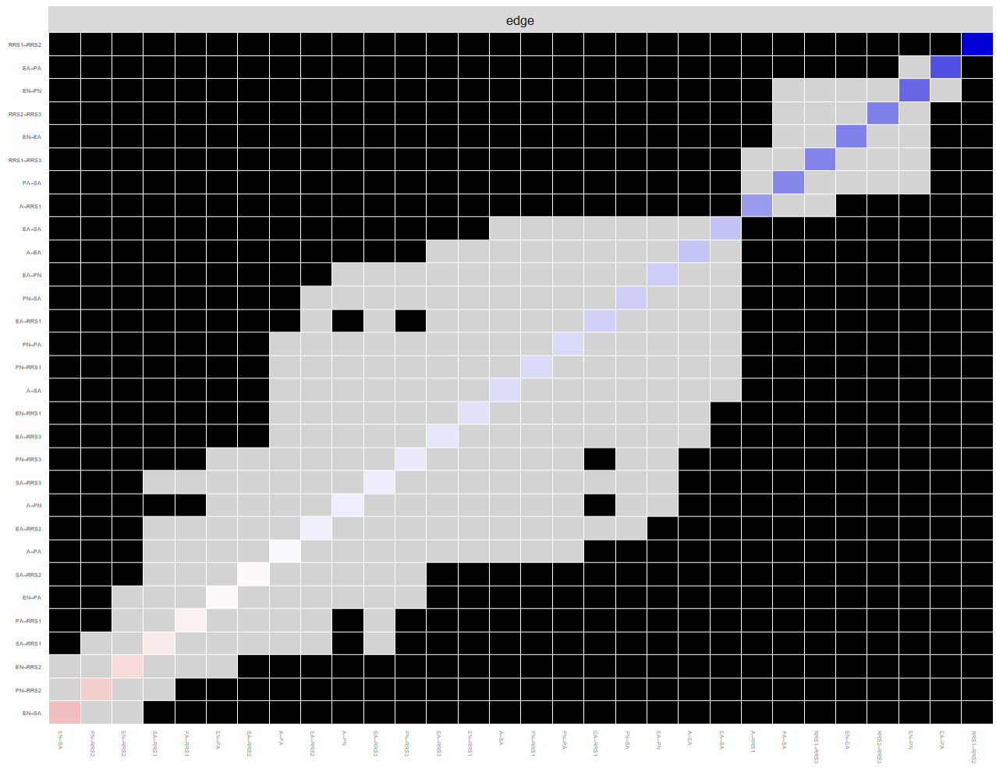

Supplementary Fig. 3. Bootstrapped difference test for expected influence of trauma, rumination and self-injury addiction network
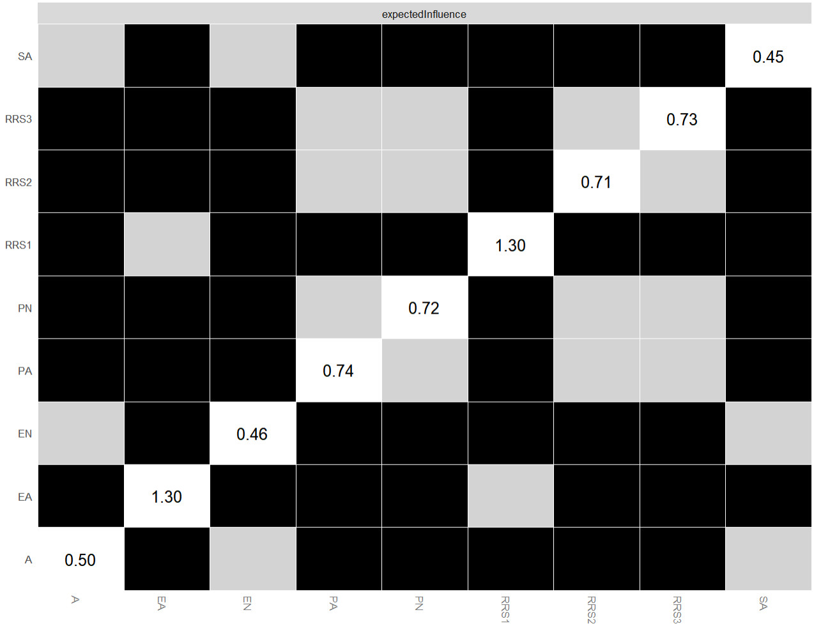

Supplementary Fig. 4. Network comparison test between addicted and non-addicted groups.

